Data Visualization Report
Goodreads Books Dataset — Turning Numbers Into Charts
From raw data to a clear, decision-supporting visual story.

Introduction
This report transforms 11,025 rows of raw Goodreads book data into five purpose-built visuals — a bar chart, a line chart, a pie chart, a histogram, and a heatmap — each chosen because it is the clearest way to answer a specific question about the data. Rather than just presenting charts, each section explains what the chart shows and why it matters, in the same way a chart would support a real business or editorial decision.

1. Who Are the Most Prolific Authors?
Chart type: Bar Chart — best for comparing categories
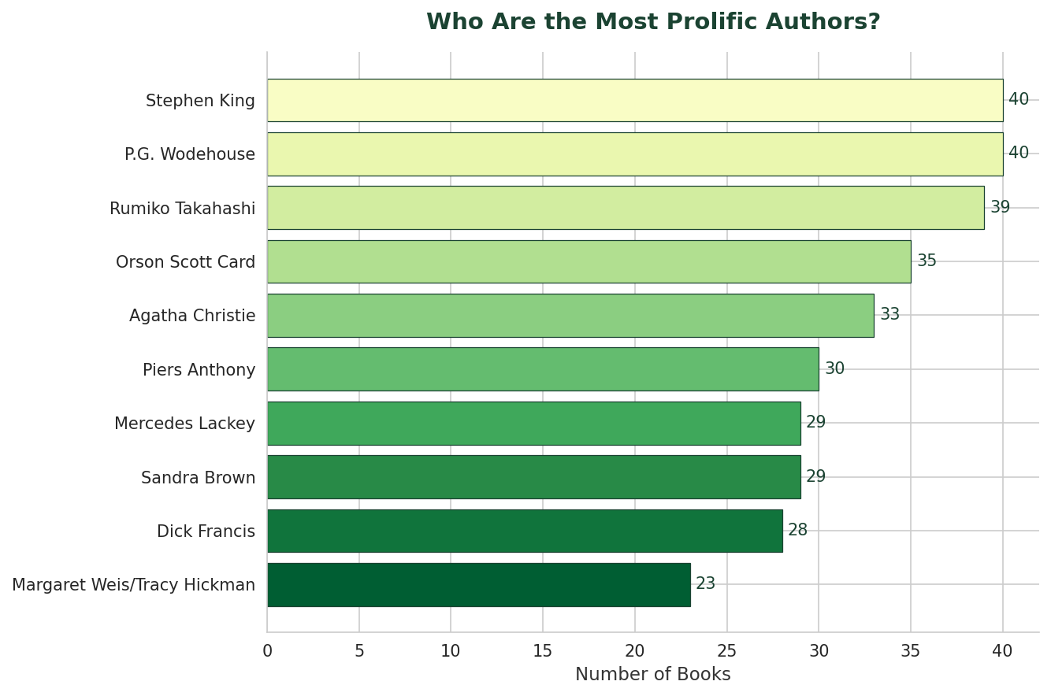

What this tells us
Stephen King leads the dataset with 40 books, tied with P.G. Wodehouse. A bar chart makes this comparison instant: instead of scanning a table of names and counts, the reader sees at a glance who dominates the catalogue.

2. Publishing Activity Over Time
Chart type: Line Chart — best for trends over time
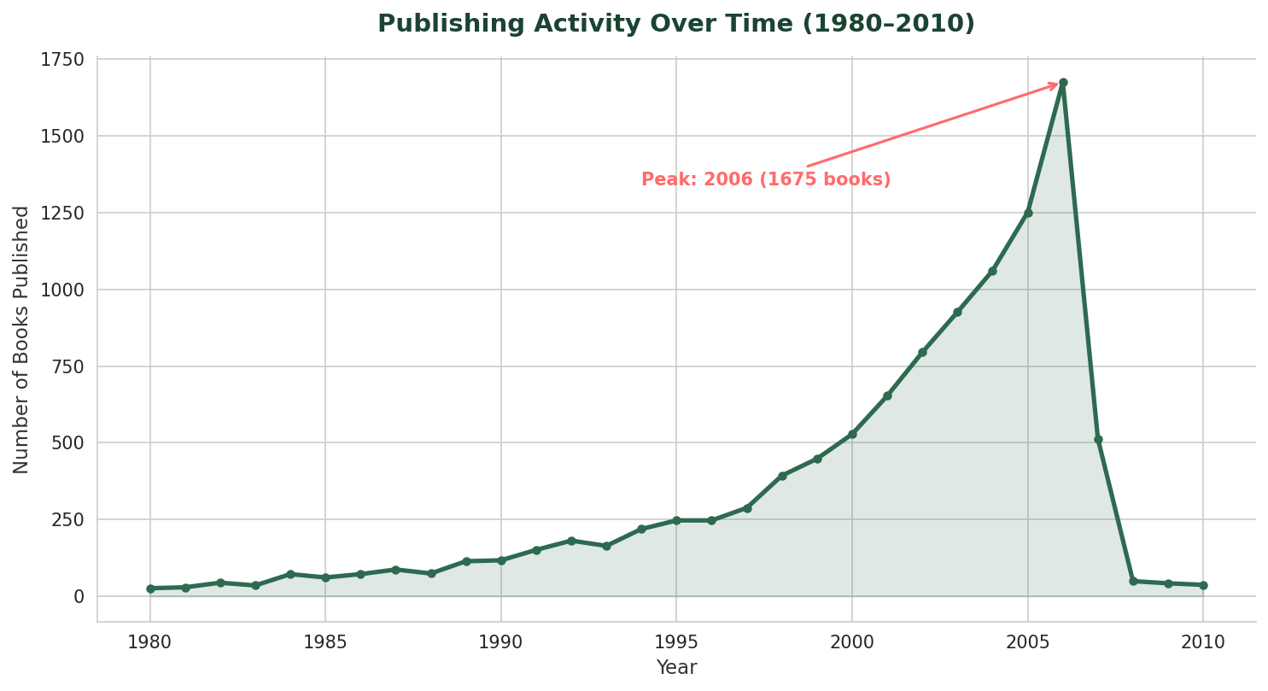

What this tells us
Publishing volume in this dataset climbs steadily from the 1980s and peaks in 2006 at 1675 books, before falling off sharply. A line chart is the right tool here because the story is about change over time — the eye follows the slope and immediately sees growth, peak, and decline, which a table of yearly counts would hide. (The drop after the peak likely reflects when this dataset snapshot was collected, not an actual publishing slowdown.)

3. What Languages Are Books Published In?
Chart type: Pie Chart — best for simple proportions, used sparingly
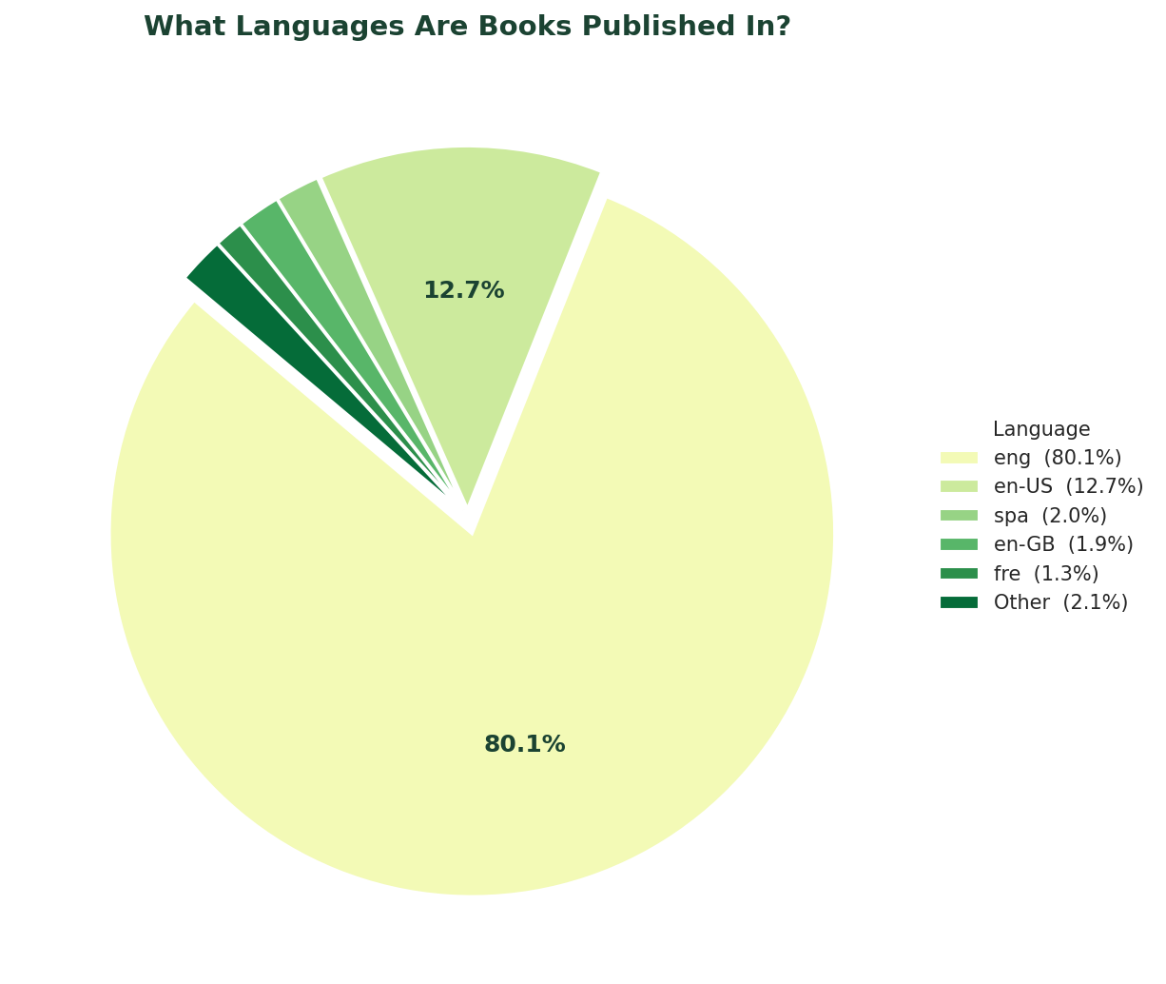

What this tells us
English ('eng') accounts for 80.1% of all books, making it by far the dominant language in the catalogue. A pie chart works well here because the question is simple — 'what share does each language hold?' — and there are few enough categories (6) that the slices stay readable. Pie charts are used sparingly in this project precisely because they get cluttered fast with more categories than that.

4. How Are Book Ratings Distributed?
Chart type: Histogram — best for the distribution/shape of a value
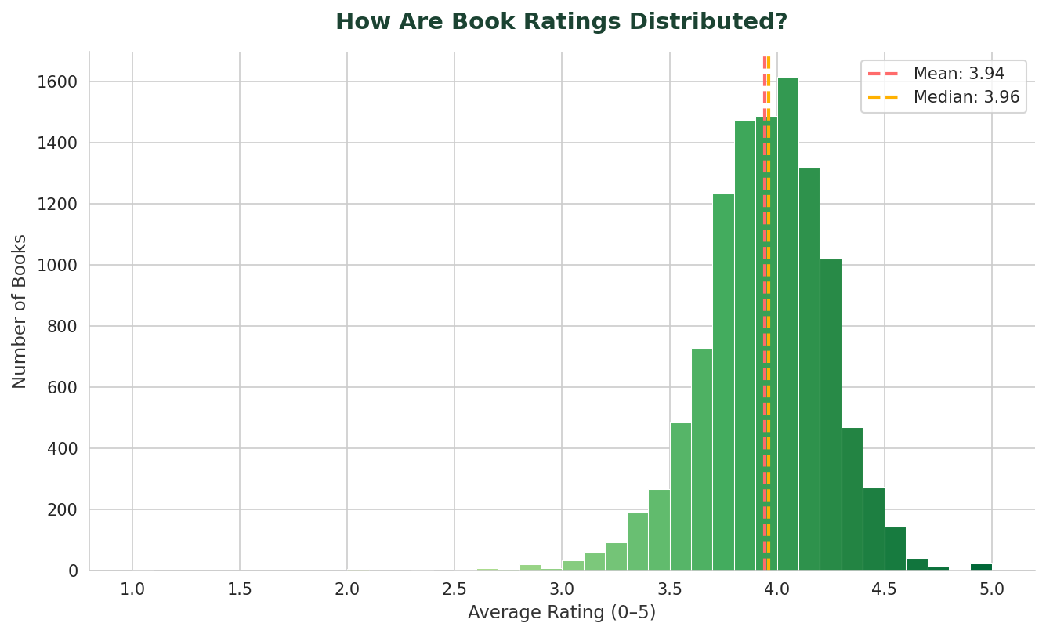

What this tells us
Most books cluster tightly between roughly 3.7 and 4.2 stars, with a mean of 3.94 and a median of 3.96 that sit almost on top of each other — a sign of a fairly symmetric, slightly left-skewed distribution rather than a few outliers pulling the average around. A histogram is the right chart for this because the question isn't about individual books, it's about the overall shape of ratings across the whole dataset.

5. Which Variables Move Together?
Chart type: Heatmap — best for correlations between variables
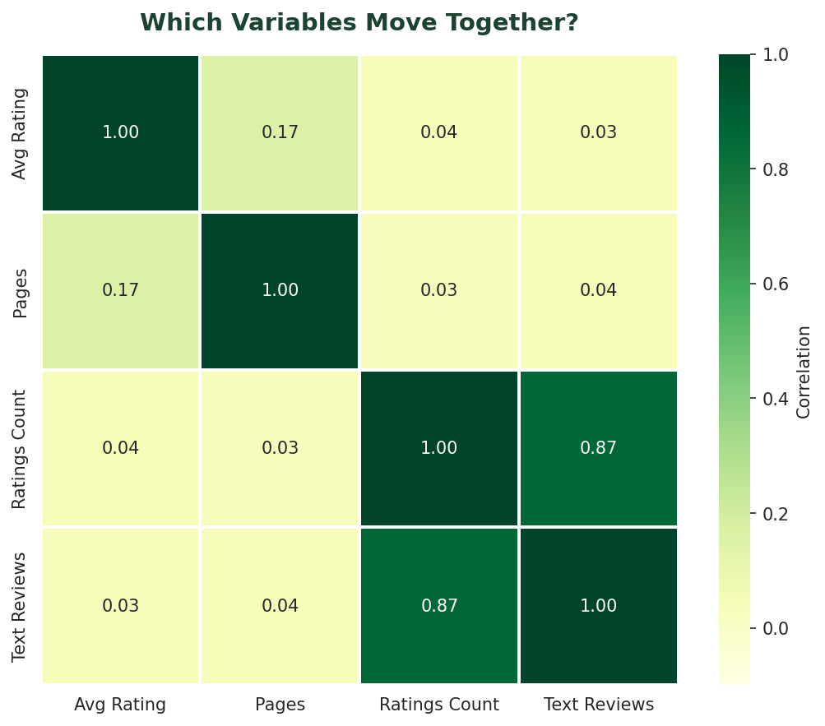

What this tells us
The heatmap reveals one standout relationship: ratings count and text reviews count are strongly correlated (0.87) — books that get rated a lot also get reviewed a lot, which makes sense, since both come from engaged readers. Everything else is weak, including average rating versus page count (0.17), meaning a book's length tells you almost nothing about how well it's rated. A heatmap is ideal here because it lets the reader scan every pairwise relationship at once instead of reading four separate correlation numbers out of context.

The Story in Plain English
Put together, these five charts tell a single coherent story about the Goodreads catalogue. The collection is overwhelmingly English-language (80.1%), concentrated among a small set of highly prolific authors led by Stephen King (40 books), and skewed toward titles published in the years leading up to 2006, when the dataset's coverage peaks at 1,675 books in a single year.
On quality and engagement: books are rated consistently well, clustering around 3.94/5, and that rating has almost no relationship to how long a book is (correlation = 0.166). What does matter is reader engagement — books that accumulate many ratings also accumulate many written reviews (correlation = 0.866), confirming that ratings count is a reliable proxy for overall reader engagement, not just popularity in isolation.

Why this matters for decisions
For a publisher or platform, this points to a clear takeaway: marketing and discovery efforts built around 'ratings count' will naturally also surface highly reviewed books, since the two move together. Meanwhile, page count is not a useful signal for predicting reader satisfaction and shouldn't be used to filter or recommend titles. Visualizing this — rather than only stating the correlation numbers — makes the pattern immediately convincing and easy to act on.

